ManMon

MSBD Data Center Monitoring System

Table of Contents
1. Introduction 3
2. Overall Architecture 3
3.Controller Unit 4
3.1 Setup Raspberry Pi Environment 4
3.2 Tools and Components 6
6
3.3 Components which actually used in ManMon: 7
3.4 Components which were recommended and also available as backup: 8
3.5 Controller Unit and It’s Responsibilities 8
3.6 Circuit Diagram 9
3.7 Library Matrix 10
4. ManMon Agent 11
4.1 Environment Setup 11
4.2 Components Definition 12
4.3 ManMon Communication Layers 12
4.4 Request Mapping 15
4.5 ManMon Future Development Plan 18
5. Manmon (Front-End) 19
5.1 Environment Setup 19
6. Apendix 20

1. Introduction
ManMon is Data Center monitoring system of Mangrove Systems Bangladesh. It will monitor the data center environment and control relay switch.

2. Overall Architecture
ManMon

Instructions
Status

ManMon Server
Control Unit
Data
Center
Environment Status

Raspberry Pi

On/Off
Relay
Noise

Humidity
Light
Lamp
Temperature

Figure 1: ManMon Component Architecture

3.Controller Unit

3.1 Setup Raspberry Pi Environment
Installing Raspbian OS
Raspberry Pi OS (32-bit) with desktop and recommended software
version : Auigust 2020
Kernel version : 5.4
Step 1: Download Raspbian
Step 2: Unzip the file
Step 3: Write the disc image to your microSD card using Imager (Raspbian Imager)
Step 4: Put the microSD card in your Pi and boot up

Install Python3

#sudo apt update

#sudo apt install python3

Install pip3

#sudo apt-get update

#sudo apt-get -y install python3-pip

Install RPi.GPIO Python Library

#wget https://pypi.python.org/packages/source/R/RPi.GPIO/RPi.GPIO-0.5.11.tar.gz
#tar -xvf RPi.GPIO-0.5.11.tar.gz
#cd RPi.GPIO-0.5.11
#sudo python setup.py install
Reference: https://www.raspberrypi-spy.co.uk/2012/05/install-rpi-gpio-python-library/

Install PIGPIO Library

#sudo wget https://github.com/joan2937/pigpio/archive/master.zip
#unzip master.zip
#cd pigpio-master
#sudo make
#sudo make install
Reference : http://abyz.me.uk/rpi/pigpio/download.html

after installing pigpio library we need to start the pigpio service,

#sudo pigpiod

every time, raspberry pi restarts we must need to start this service

Install smbus

#sudo apt-get update

#sudo apt install python3-smbus

Install I2C

#sudo apt-get update

#sudo apt-get install i2c-tools

If this error occurs
Error:Could not open file `/dev/i2c-1': No such file or dire
https://www.raspberrypi.org/forums/viewtopic.php?t=115080

Note: set

Install Cherrypi Server

#git clone https://github.com/cherrypy/cherrypy
#cd cherrypy
#python3 setup.py install

3.2 Tools and Components
We are going to use
1. Raspbian as OS of raspberry pi 4 Model-B
2. Thonny IDE
3. cherrypi server
4. spring boot(Back End),AngularJs(Front End)

Metric | Purpose | Sensor/  Component | Model (Clone) | Unit Price | No. of Units | Price
Humidity,Temperature | Receive Humidity | Humidity Sensor * 3 | AM2301 | 800 | 2 | 300
Noise | Receive Sound | Sound Sensor | FC-04 | 650 | 1 | 650
Camera* | Visualize Data Center | Raspberry Pi Cam | ROB-00350 | IP?
Light | Sense Light Intensity | Light Sensor | BH1750 | 53 | 3 | 160
Lamp | Environment Lighting | LED Bulb | 20 watt | 300 | 1 | 300
Relay | Convert DC signal to AC | Relay Switch  (4 Channel) | MIS-00362 | 200 | 2 | 400
Raspberry Pi 4 | Server Computer | Raspberry Pi 4(4GB) | DEV-00110/ M-B | 6300 | 1 | 6300
Memory card | Hard disk Raspberry | 64GB | SanDisk class10 | 1800 | 1 | 1800
Micro HDMI to HDMI | Raspberry Pi 4 to connect to a HDMI monitor | Cable | C&C-00236 | 385 | 1 | 385
Casing | https://www.electronics.com.bd/Acrylic-Case-for-Raspberry-Pi-4-Model-B-Raspberry-Pi-Case-with-Cooling-Fan-Black-and-Clear-electronics-com-bd |  | Raspberry Pi 4 | 446 | 1 | 446
Soldering | Soldering iron-60W (tatal) |  | TOL-00018
Soldering | ran
Soldering | rojon
Jumper cables | M2F |  |  | 40
Jumper cables | M2M |  |  | 40
Jumper cables | F2F |  |  | 40
Bread board
PCB |  | 20 yard
Raspberry Pi 4  power adapter |  |  | MIS-00490
AC cables
Ethernet Cable |  | 1 piece
Glue gun | gluing | 1
Tatal holder | To hold tatal | 1
Cutter | Cutting wires | 1
Tester |  | 1
Plus |  | 1
Screw driver | Screwing | 2

3.3 Components which actually used in ManMon:
Sensor | Model
Humidity Sensor | AM2301
Sound sensor | FC-04
Light sensor | BH1750

3.4 Components which were recommended and also available as backup:
Sensor | Model
Humidity Sensor | AM2301,DHT22,DHT11
Sound sensor | FC-04
Light sensor | BH1750

3.5 Controller Unit and It’s Responsibilities
A. Publishes and Receives Environment Data and Instructions to and from ManMon Server
I. Tasks
- Receives Instructions From ManMon.
- Sends Environment Data to ManMon
II. Technical
- Programming Language : Python3.
- Communication : Web Socket
- Data Format : JSON

B. Receives and Sends Instructions and Environment Data from and to Raspberry Pi
I. Tasks
- Receives Environment Data from Raspberry Pi.
- Sends Instructions to Raspberry Pi
II. Technical
- Module : Raspberry Pi 4
- Communication : Serial port
- Sensors: Humidity, Noise , Temperature , Camera , Light
-Device : Lamp

3.6 Circuit Diagram
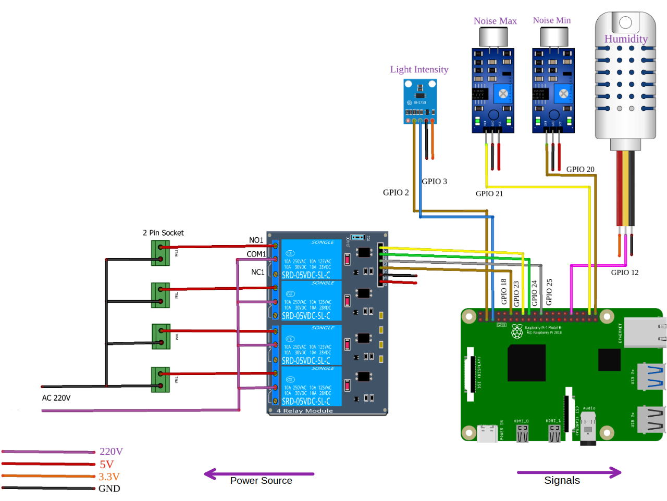

3.7 Library Matrix

Sensors | Rpi.GPIO Library | PIGPIO | DHT22 Library | Smbus Library
Humidity and Temperature Sensor | x | √ | √ | x
Light Intensity sensor | x | x | x | √
Sound Sensor | √ | x | x | x
Relay | √ | x | x | x

Sensors:

1. Humidity Sensor(AM2301) x 1
2. Light Intensity Sensor(BH1750) x 1
3. Noise Sensor x 2 (Reference :https://bdspeedytech.com/index.php?route=product/product&product_id=1399&search=sound+sensor )
Sensors:
1. 4-channel Relay x 1

4. ManMon Agent

4.1 Environment Setup

Tools we need to setup:
- OpenJDK 14.0.1
- Netbeans 12.0
- Maven 3.6 or higher

OpenJDK
- Download openjdk-14.0.1_linux-x64_bin.tar.gz
- Extract ‘openjdk-14.0.1_linux-x64_bin.tar.gz’
- Move ‘openjdk-14.0.1’ folder to /usr/lib/jvm
- Set JAVA_HOME and PATH with this following command
$ export JAVA_HOME=/usr/lib/jvm/jdk-14.0.1
$ export PATH=$JAVA_HOME/bin:$PATH
- Check JDK version
$ java -version
Download Ref: https://www.oracle.com/java/technologies/javase/jdk14-archive-downloads.html
Netbeans
- Download Apache-NetBeans-12.1-bin-linux-x64.sh
- Install Netbeans
References: https://netbeans.apache.org/download/nb121/nb121.html
Maven
- sudo apt install maven

4.2 Components Definition
Web Socket: The Web Socket protocol, provides a standardized way to establish a full-duplex, two-way communication channel between client and server over a single TCP connection.

Web Socket Endpoint: /portfolio is the HTTP URL for the endpoint to which a Web Socket (or SockJS)
client needs to connect for the Web Socket handshake.

STOMP: Simple Text Oriented Messaging Protocol. It is designed to address a minimal subset of commonly used messaging patterns. Although STOMP is a text-oriented protocol, message payloads can be either text or binary.
Clients can use the SEND or SUBSCRIBE commands to send or subscribe for messages, along with a destination header that describes what the message is about and who should receive it.

Messages Mapping: STOMP messages whose destination header begins with /app are routed to @MessageMapping methods in @Controller classes.

Topic: Whose destination header begins with /topic. /topic is the built-in message broker for subscriptions and broadcasting and route messages. Client SUBSCRIBE to a broker to get published/broadcasted messages by the broker.

Fetch: In this case Fetch means data retrieve from the application database. We do this using HTTP.GET request method.

Response: In response of HTTP.GET request we get a response which is our desired data.

Scheduler: Scheduler is a Spring Boot @Component Class. Where we can execute a method after a fixed time continuously.

Sensor-Controller: Sensor-Controller is simple HTTP-Server, built using Python3 CherryPi framework. This server receives HTTP request to retrieve environment status from the sensor and also execute device control instructions given by the monitor admin.

References:
1.https://docs.spring.io/spring-framework/docs/current/spring-framework-reference/web.html#websocket

4.3 ManMon Communication Layers

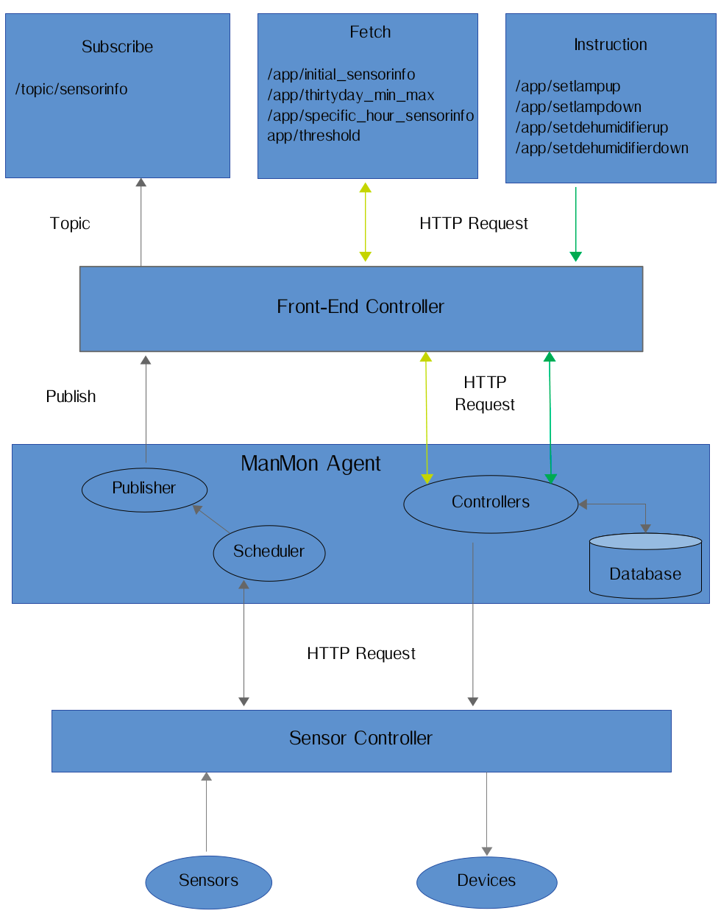

4.4 Request Mapping

Front-End «» Agent Request Mapping
SN | Frontend «» Agent | Type | Response | Description
 |  |  |  | Purpose | Steps
 | /topic/sensorinfo | Subscribe  (initial page load) | /sensorinfo | Scheduled sensor info in every 10 second | - Agent sends http request to sensor controller and in response get current environment status  - Agent add noiseLevel and sensors min-max status with environment status and publish to clients
 | /thirtyday_min_max | GET  (initial page load) | /current_date_min_max | Fetch Thirty day min-max value of sensors | - Agent fetch last thirty days min-max value of sensors from DB and sends to client
 | /threshold | GET  (initial page load) | /threshold | Fetch Sensors threshold value | - Agent fetch threshold value of sensors from DB and send to clients
 | /initial_sensorinfo | GET  (initial page load) | /initial_sensorinfo | Fetch last 15 minutes sensorinfo to client | - Agent fetch last 15 minutes sensorinfo from DB sends to client
 | /specific_hour_sensorinfo | GET  (initial page load or user request) | /specific_hour_sensorinfo | Fetch specific hours sensorinfo to client | - Agent fetch specific date-hour sensorinfo from DB and sends to client
 | /setlampup | GET | /setlampup | Set Lamp on | - Agent sends http request to sensor controller and in response get Lamp status  - Agent sends Lamp status to client
 | /setlampdown | GET | /setlampdown | Set Lamp off | - Agent sends http request to sensor controller and in response get Lamp status  - Agent sends Lamp status to client
 | /setdehumidifierup | GET | /setdehumidifierup | Set Dehumidifier on | - Agent sends http request to sensor controller and in response get Dehumidifier status  - Agent sends Dehumidifier status to client
 | /setdehumidifierdown | GET | /setdehumidifierdown | Set Dehumidifier off | - Agent sends http request to sensor controller and in response get Dehumidifier status  - Agent sends Dehumidifier status to client

Agent «» Sensor-Controller Request Mapping
SN | Agent «» Sensor | Type | Response | Description
 |  |  |  | Purpose | Steps
 | /sensorinfo | GET | Environment status JSON | Fetch environment status in every 10 second | - Scheduler sends http request in every 10 second to sensor-controller  - In response get Environment status
 | /setlampup | GET | ‘Relay for Lamp is set to On’ | Lamp on | - Sends http request to sensor-controller  - In response get Lamp status
 | /setlampdown | GET | ‘Relay for Lamp is set to Off’ | Lamp off | - Sends http request to sensor-controller  - In response get Lamp status
 | /setdehumidifierup | GET | ‘Relay for Dehumidifier is set to On’ | Dehumidifier on | - Sends http request to sensor-controller  - In response get Dehumidifier status
 | /setdehumidifierdown | GET | ‘Relay for Dehumidifier is set to Off’ | Dehumidifier off | - Sends http request to sensor-controller  - In response get Dehumidifier status

4.5 ManMon Future Development Plan

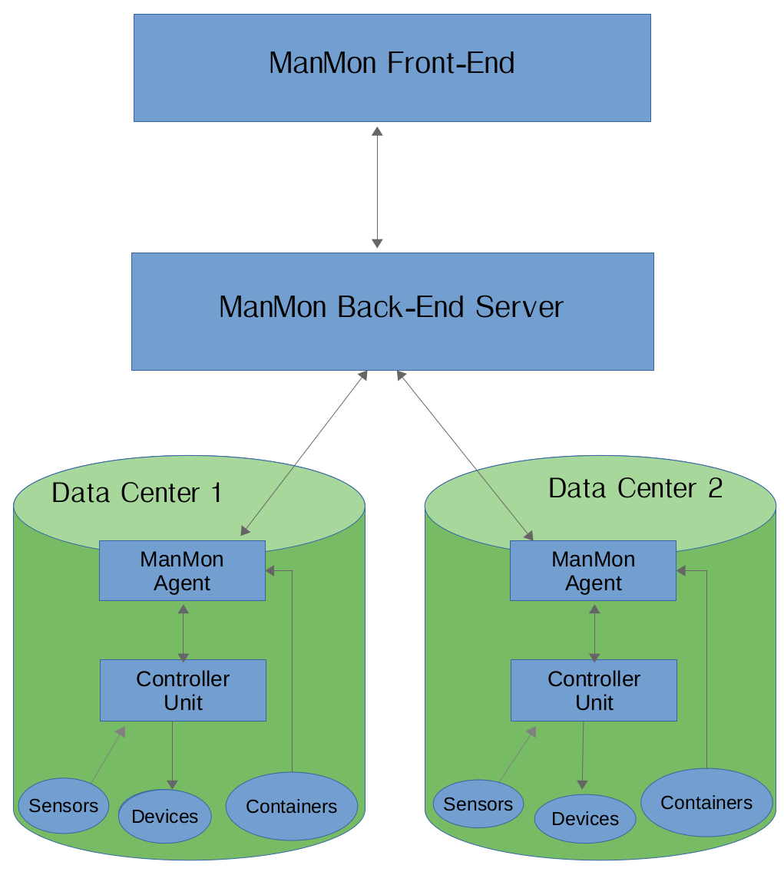

5. Manmon (Front-End)

5.1 Environment Setup

Tools we need to setup:
- Node (Latest version)
- VS Code

Node Installation :

nvm install node

If nvm is not installed on your machine then install nvm first

Installing nvm:

curl -o- https://raw.githubusercontent.com/nvm-sh/nvm/v0.35.3/install.sh | bash

VsCode Installation :

Download and Install
https://go.microsoft.com/fwlink/?LinkID=760868

6. Appendix
RPI.GPIO
Reference: https://www.raspberrypi-spy.co.uk/2012/05/install-rpi-gpio-python-library/
PIGPIO
Reference : http://abyz.me.uk/rpi/pigpio/download.html
OpenJDK
Download openjdk-14.0.1_linux-x64_bin.tar.gz
Netbeans
References: https://netbeans.apache.org/download/nb121/nb121.html

